**Module -4**

**1. Resource Monitoring Techniques**

“Resource monitoring is crucial for ensuring the efficient use of resources in any IT environment. Here are some common techniques:

Performance Monitoring: This involves tracking the performance of various system components like CPU, memory, disk usage, and network activity. Tools like Nagios, Zabbix, and Prometheus are widely used for this purpose.

Log Monitoring: Collecting and analyzing log files from different systems to detect anomalies, errors, or security breaches. Tools like Splunk, ELK Stack (Elasticsearch, Logstash, Kibana), and Graylog are popular choices.

Application Performance Monitoring (APM): Focuses on monitoring the performance of applications to ensure they are running smoothly. Tools like New Relic, AppDynamics, and Dynatrace are commonly used.

Network Monitoring: Involves monitoring network traffic, bandwidth usage, and detecting network issues. Tools like SolarWinds, PRTG Network Monitor, and Wireshark are effective for network monitoring.

Cloud Resource Monitoring: Monitoring cloud resources like virtual machines, storage, and databases. Cloud providers offer native tools like AWS CloudWatch, Azure Monitor, and Google Cloud Operations Suite.”

**2. How to Access Compute (Windows and Linux) from the Internet**

“Accessing compute resources over the internet requires secure methods and tools:

* Remote Desktop Protocol (RDP): For accessing Windows machines. RDP is built into Windows and allows users to connect to another computer over a network connection. Security measures include using strong passwords, enabling Network Level Authentication (NLA), and using VPNs to secure the connection.
* Secure Shell (SSH): For accessing Linux machines. SSH provides a secure channel over an unsecured network. Tools like PuTTY, OpenSSH, and MobaXterm are commonly used. Security practices include using key-based authentication, disabling root login, and changing the default SSH port.
* Virtual Private Network (VPN): VPNs create a secure tunnel between the user’s device and the network, ensuring that data transmitted over the internet is encrypted. Tools like OpenVPN, Cisco AnyConnect, and NordVPN are popular choices.
* Web-Based Management Consoles: Cloud providers offer web-based consoles to manage and access compute resources. Examples include AWS Management Console, Azure Portal, and Google Cloud Console. These consoles often support multi-factor authentication (MFA) and role-based access control (RBAC) for enhanced security.”

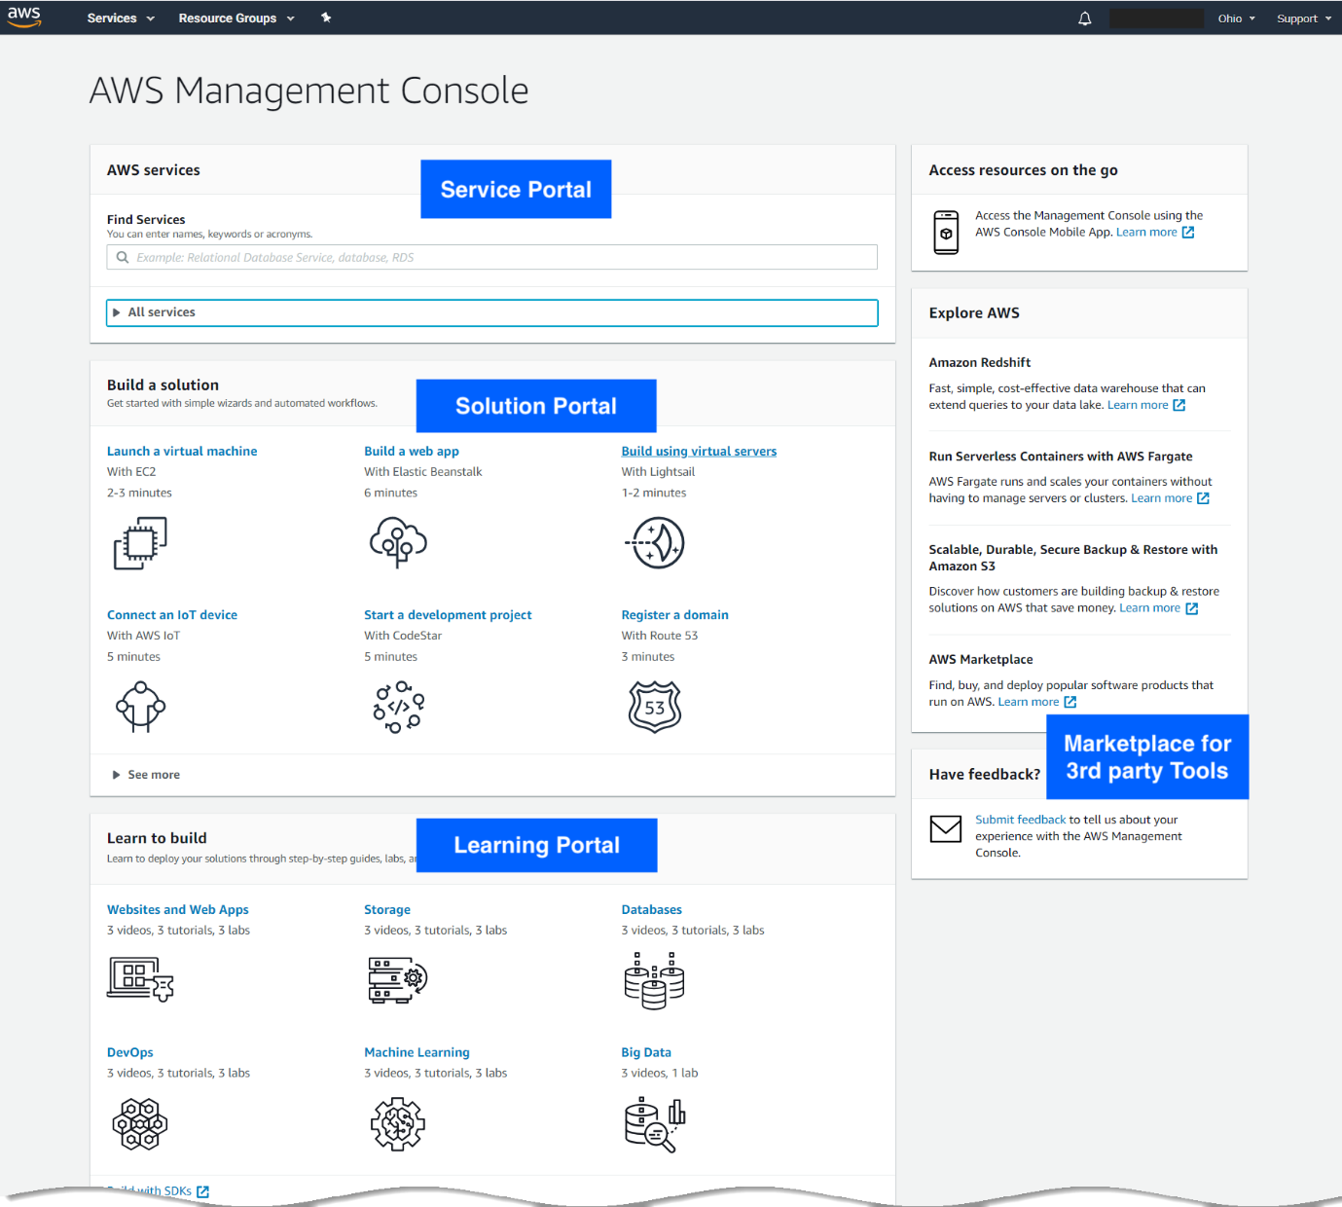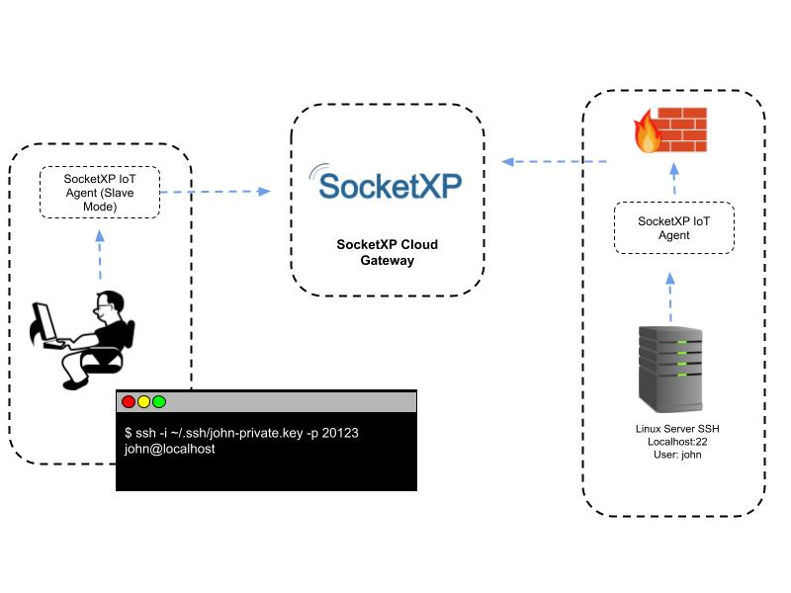

**3. Encryption Technologies and Methods**

“Encryption is essential for protecting data from unauthorized access. Here are some key technologies and methods:

Symmetric Encryption: Uses the same key for both encryption and decryption. It’s fast and efficient but requires secure key management. Common algorithms include AES (Advanced Encryption Standard) and DES (Data Encryption Standard).

Asymmetric Encryption: Uses a pair of keys (public and private) for encryption and decryption. It’s more secure but slower than symmetric encryption. Common algorithms include RSA (Rivest-Shamir-Adleman) and ECC (Elliptic Curve Cryptography).

Hash Functions: Generate a fixed-size hash value from input data, ensuring data integrity. Common algorithms include SHA-256 (Secure Hash Algorithm) and MD5 (Message Digest Algorithm).

Transport Layer Security (TLS): Ensures secure communication over networks. It encrypts data in transit between clients and servers. TLS is widely used in HTTPS, email, and VPNs.

End-to-End Encryption (E2EE): Ensures that data is encrypted on the sender’s device and only decrypted on the recipient’s device. This method is used in messaging apps like WhatsApp and Signal.”

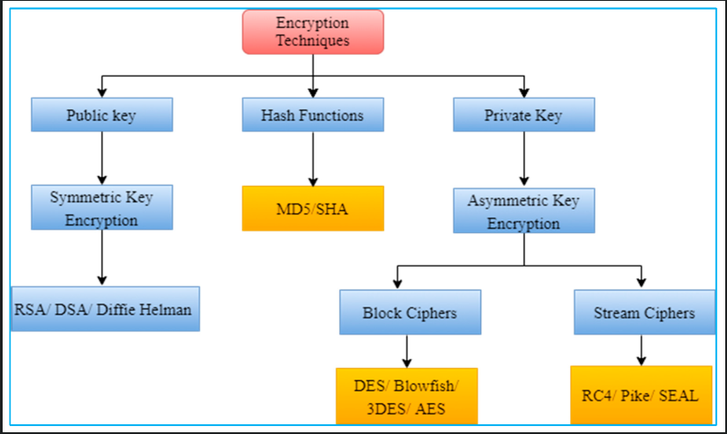

**4.Network Security in Cloud, Compute Security, and Storage Security**

“Securing cloud environments involves multiple layers of security measures:

**Network Security:**

Firewalls: Control incoming and outgoing network traffic based on security rules. Cloud providers offer services like AWS Security Groups, Azure Network Security Groups, and Google Cloud Firewalls.

Intrusion Detection and Prevention Systems (IDPS): Monitor network traffic for suspicious activity. Tools like Snort, Suricata, and cloud-native services like AWS GuardDuty are used.

Virtual Private Cloud (VPC): Isolate cloud resources within a private network. VPCs provide control over network configuration and security.

**Compute Security:**

Instance Hardening: Securing virtual machines by disabling unnecessary services, applying patches, and configuring security settings.

Access Controls: Implementing RBAC and IAM to ensure only authorized users can access compute resources.

Endpoint Protection: Using antivirus, anti-malware, and endpoint detection and response (EDR) solutions to protect compute instances.

**Storage Security:**

Encryption: Encrypting data at rest and in transit to protect it from unauthorized access. Cloud providers offer services like AWS KMS (Key Management Service), Azure Key Vault, and Google Cloud KMS.

Access Controls: Implementing fine-grained access controls to ensure only authorized users can access storage resources.

Data Backup and Recovery: Regularly backing up data and having a disaster recovery plan in place to ensure data availability.”

